**Lab 3: Creating and configuring VLAN and VLAN Trunking.**

**Topology 1: VLAN**

|  |  |  |  |  |  |  |  |
| --- | --- | --- | --- | --- | --- | --- | --- |
| **Device** | **Interface** | **IPv4 Address** | **Subnet Mask** | **Switch Port** | **VLAN No** | **VLAN Name** | **Link** |
| Host1 | NIC | 172.17.10.21 | 255.255.0.0 | Fa0/1 | 10 | CSIT | Access |
| Host2 | NIC | 172.17.10.22 | 255.255.0.0 | Fa0/2 | 10 | CSIT | Access |
| Host3 | NIC | 172.17.10.23 | 255.255.0.0 | Fa0/11 | 20 | BCA | Access |
| Host4 | NIC | 172.17.10.24 | 255.255.0.0 | Fa0/12 | 20 | BCA | Access |

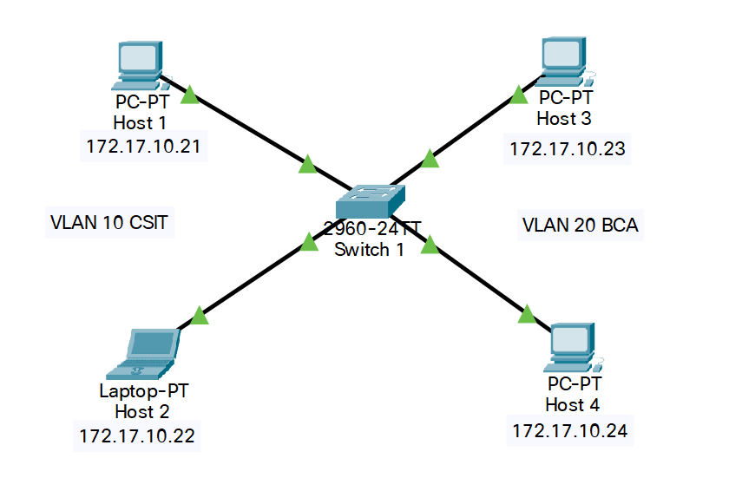

* Design the given topology.
* Assign the Layer 3 address to all hosts.
* Configure the switch to create two VLANS
  + VLAN 10 as CSIT
  + VLAN 20 as BCA
* Assign VLANs to all the PC according to Addressing Table.
* From the command prompt on each Host, do ping test between Hosts on the same and different VLAN and write the output.
  + Can Host1 ping Host2?
  + Can Host3 ping Host4?
  + Can Host1 ping Host3 and Host4?
  + Can Host3 ping Host1 and Host2?

**Topology 2: VLAN Trunking**

|  |  |  |  |  |  |  |  |
| --- | --- | --- | --- | --- | --- | --- | --- |
| **Device** | **Interface** | **IPv4 Address** | **Subnet Mask** | **Switch Port** | **VLAN No** | **VLAN Name** | **Link** |
| Host1 | NIC | 172.17.10.21 | 255.255.0.0 | S1; Fa0/1 | 10 | CSIT | Access |
| Host2 | NIC | 172.17.10.22 | 255.255.0.0 | S1; Fa0/2 | 10 | CSIT | Access |
| Host3 | NIC | 172.17.10.23 | 255.255.0.0 | S1; Fa0/11 | 20 | BCA | Access |
| Host4 | NIC | 172.17.10.24 | 255.255.0.0 | S1; Fa0/12 | 20 | BCA | Access |
| Host5 | NIC | 172.17.10.25 | 255.255.0.0 | S2; Fa0/3 | 10 | CSIT | Access |
| Host6 | NIC | 172.17.10.26 | 255.255.0.0 | S2; Fa0/13 | 20 | BCA | Access |
| Switch1 | Fa0/24 | - | - | S2; Fa0/24 |  |  | Trunk |

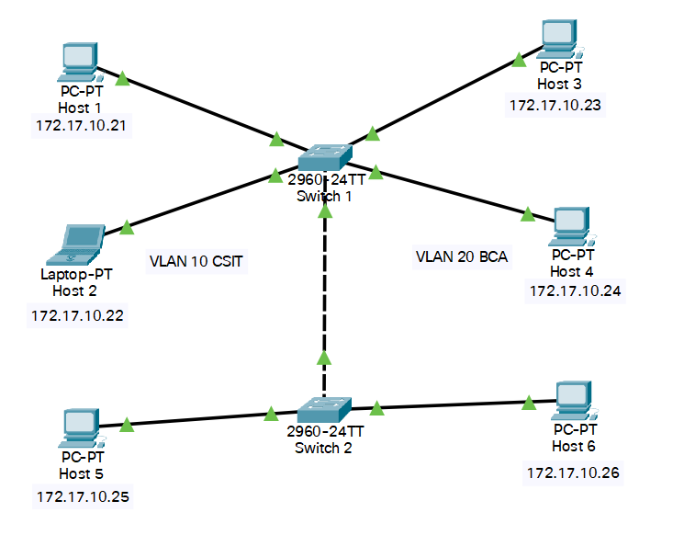

* Design the given topology.
* Assign the Layer 3 address to all hosts.
* Configure the switches S1 and S2 to create two VLANS in each
  + VLAN 10 as CSIT
  + VLAN 20 as BCA
* Assign VLANs to all the PC according to Addressing Table.
* From the command prompt on each Host, do ping test between Hosts on the same and different VLAN and write the output.
  + Can Host1 ping Host2 and Host5?
  + Can Host3 ping Host4 and Host6?
  + Can Host6 ping Host1?
  + Can Host5 ping Host3?

**Lab 4: Implementation of Static Routing Configuration**

Topology

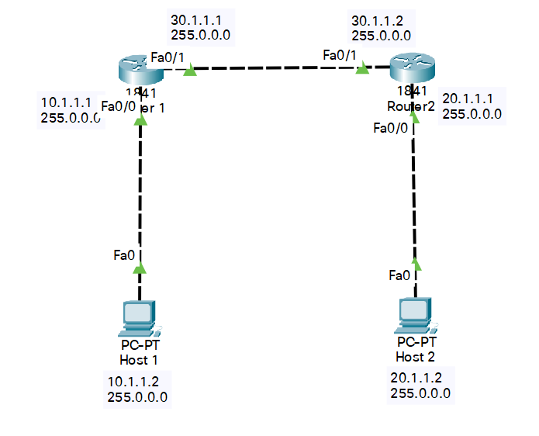

|  |  |  |  |  |  |
| --- | --- | --- | --- | --- | --- |
| **Device** | **Interface** | **IPv4 Address** | **Subnet Mask** | **Gateway** | **Link Ports** |
| Host1 | NIC | 10.1.1.2 | 255.0.0.0 | 10.1.1.1 | R1; Fa0/0 |
| Host2 | NIC | 20.1.1.2 | 255.0.0.0 | 20.1.1.1 | R2; Fa0/0 |
| Router1 | Fa0/0 | 10.1.1.1 | 255.0.0.0 |  |  |
| Fa0/1 | 30.1.1.1 | 255.0.0.0 |  |  |
| Router2 | Fa0/0 | 20.1.1.1 | 255.0.0.0 |  |  |
| Fa0/1 | 30.1.1.2 | 255.0.0.0 |  |  |

* Design the given topology.
* Assign the IP address to all hosts and routers according to Addressding Table.
* Configure the routers with static route.
* From the command prompt on each host, ping between hosts. Write the output.
  + Can Host1 ping Host2?
  + Can Router1 ping Host2?
  + Can Host1 ping Router2?

**Lab 5: Implementation of Dynamic Routing (RIP) Configuration.**

**Topology**



|  |  |  |  |  |  |
| --- | --- | --- | --- | --- | --- |
| **Device** | **Interface** | **IPv4 Address** | **Subnet Mask** | **Gateway** | **Link Ports** |
| Host1 | NIC | 10.1.1.2 | 255.0.0.0 | 10.1.1.1 | R1; Fa0/0 |
| Host2 | NIC | 20.1.1.2 | 255.0.0.0 | 20.1.1.1 | R2; Fa0/0 |
| Router1 | Fa0/0 | 10.1.1.1 | 255.0.0.0 |  |  |
| Fa0/1 | 30.1.1.1 | 255.0.0.0 |  |  |
| Router2 | Fa0/0 | 20.1.1.1 | 255.0.0.0 |  |  |
| Fa0/1 | 30.1.1.2 | 255.0.0.0 |  |  |

* Design the given topology.
* Assign the IP address to all hosts and routers according to Addressding Table.
* Configure the routers with dynamic route.
* From the command prompt on each host, ping between hosts. Write the output.
  + Can Host1 ping Host2?
  + Can Router1 ping Host2?
  + Can Host1 ping Router2?